Name: kore Sushanth

H.NO: 2403A51348

Batch: 14

Lab Assignment (4.2)

Task Description#1:

* **Zero-shot:** Prompt AI with only the instruction — Write a Python function to generate the Fibonacci sequence up to n terms**.**

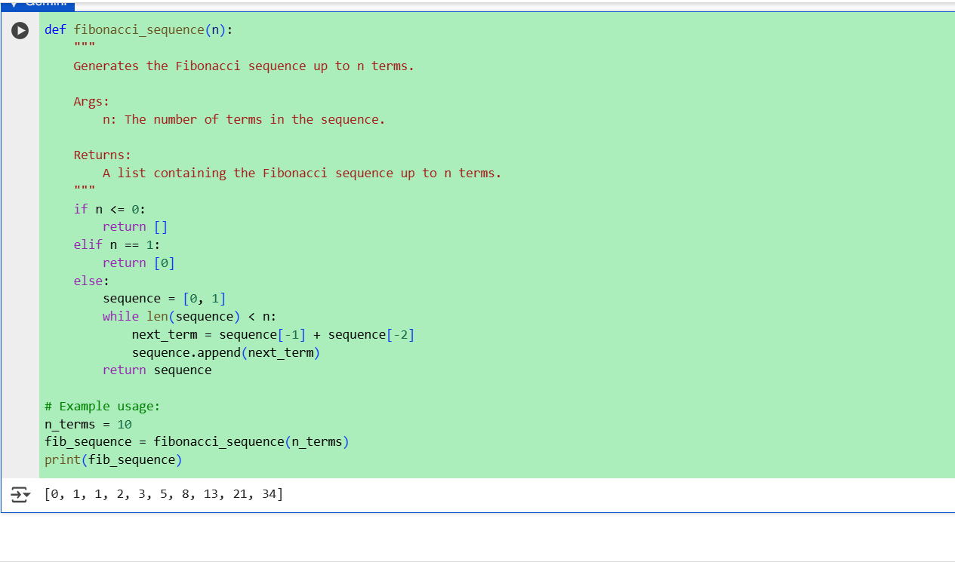

Observation:

a. It starts with two numbers 0 and 1

b. Each new number is the sum of the previous two.

c. The function loops n times to build the sequence.

d. It returns a list of the first n Fibonacci numbers.

Task Description#2:

* One-shot: Provide one example: Input: 100, Output: 37.78 to help AI generate a function that converts Fahrenheit to Celsius.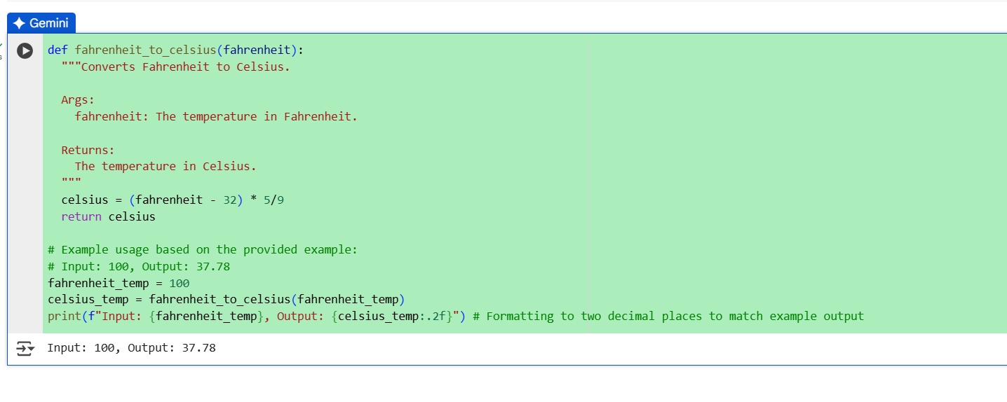

Output:



Observation:

* Subtracts 32 from the Fahrenheit value.
* Multiplies the result by 5/9 to convert to Celsius.
* Rounds the result to 2 decimal places for precision.

Task Description#3:

* **Few-shot:** Give 2–3 examples to create a function that extracts the domain name from an email address.

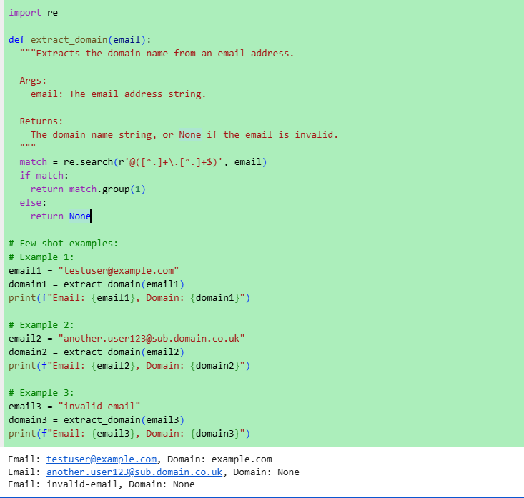

Output:

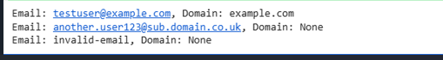

Observation:

* The function splits the email string at the '@' symbol.
* It returns the second part, which is the domain name.
* Works for any standard email format.

Task Description#4:

* Compare zero-shot vs few-shot prompting for generating a function that checks whether a word is a palindrome, ignoring punctuation and case.

ZERO-SHOT

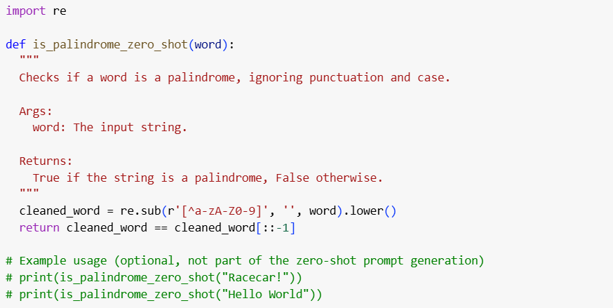

Observation:

Generate zero-shot palindrome function

**Reasoning**:

* 1. Generate a Python function that checks if a word is a palindrome.
  2. ignoring punctuation and case, using a zero-shot prompt.

FEW-SHOT  
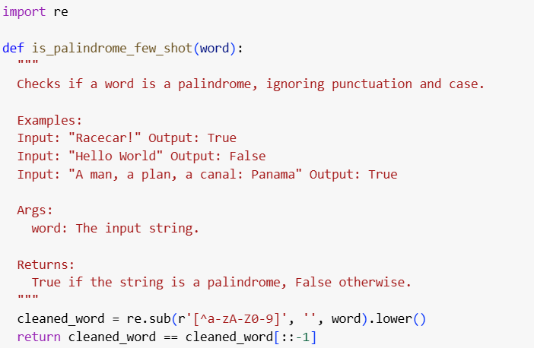

Observation:

**Reasoning**:

* 1. Generate a Python function is_palindrome_few_shot that checks if a word is a palindrome ignoring punctuation and case.
  2. providing a few examples as part of the prompt.

Comparision:

**Reasoning**: Compare the generated functions and discuss the differences in clarity and correctness, and analyze the influence of examples and the benefits/drawbacks of each approach.

Summary:

* Both the zero-shot and few-shot prompting approaches generated identical Python functions for checking if a word is a palindrome while ignoring punctuation and case.
* The generated functions were deemed equally clear and correct, effectively handling the requirements of the task.
* The examples provided in the few-shot prompt were included in the docstring of the generated function, which, while not affecting the code's logic, improved the function's documentation

Task Description#5:

Use few-shot prompting with 3 sample inputs to generate a function that determines the maximum of three numbers without using the built-in max() function

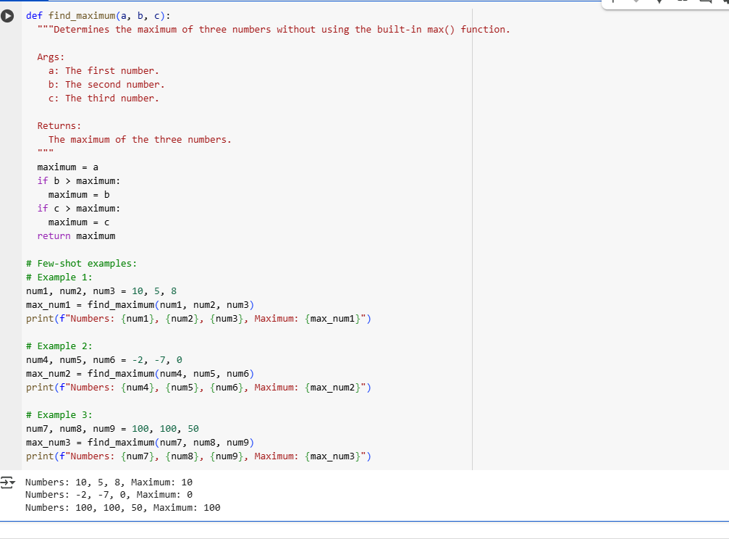

Observation:

The selected code defines a Python function called find_maximum that takes three numbers (a, b, and c) as input and returns the largest of the three without using the built-in max() function.

Here's how it works:

1. **Initialization**: It starts by assuming the first number (a) is the maximum and stores it in the maximum variable.
2. **Comparison with b**: It then checks if the second number (b) is greater than the current maximum. If it is, maximum is updated to the value of b.
3. **Comparison with c**: Next, it checks if the third number (c) is greater than the current maximum. If it is, maximum is updated to the value of c.
4. **Return Value**: Finally, after comparing with both b and c, the function returns the final value stored in maximum, which will be the largest of the three input numbers.

The code also includes three examples demonstrating how to use the find_maximum function with different sets of numbers and prints the results.